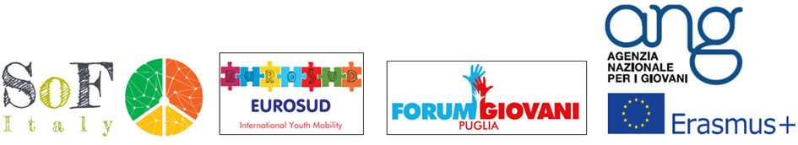

PARTICIPANT APPLICATION FORM

TRAINING COURSE

Stay Healthier Outside
07-14 NOVEMBER 2016
Bari, Italy

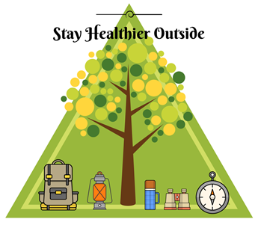

Project hosted by SOF under Erasmus+ programme

Part I

A. Personal details
Name and surname:
Gender (Male / Female):
Date of birth:
Profession / occupation:
City and country of residence:
Special needs (e.g. food, disability, others, please specify):
B. Contact details
Address:
E-mail:
Mobile telephone:
Facebook / Twitter link:

Part II

What is your personal / professional experience in relation to the theme of the project?
What previous Council of Europe, Youth in Action, Erasmus + or any other international youth activities have you attended? Please specify the name and the dates of the activities.
What is your motivation to attend this experience?

Please write your possible travel itinerary

Country:
Travelling from (name of city):

Date and time of arrival:
Airline:
Arrival airport:
Departure time (flight):
Departure time-point (train station/bus station):
Notes:

Submit to your sending organization.
Participating organisation and contacts

SOF ITALY, ITALY (APPLICANT)
sofngo@gmail.com

INTERNATIONAL CENTER FOR PEACE AND INTEGRATION (ICPI), GEORGIA (PROJECT COORDINATOR)
khatuna_chaladze@yahoo.com aphilauri@yahoo.com gocha1gelashvili@gmail.com

FUNDACJA INICJATYW SPOLECZNYCH, POLAND
Fis@fis.org.pl

ASOCIATIA TINERILOR ACTIVI CIVIC, ROMANIA
atac.romania2010@gmail.com laurpetrea@gmail.com

"YOUTH BREATH" YOUTH SUPPORT NGO, ARMENIA
anijanyan@gmail.com

ULUSLARARASI GENCLIK DERNEGI, TURKEY
fatihgokyildiz34@gmail.com uluslararasigenclikder@gmail.com

NON-GOVERNMENT ORGANIZATION "UNIT", UKRAINE
helen.manko@gmail.com

WORLD YOUTH ALLIANCE MIDDLE EAST, LEBANON
jessica@wya.net

